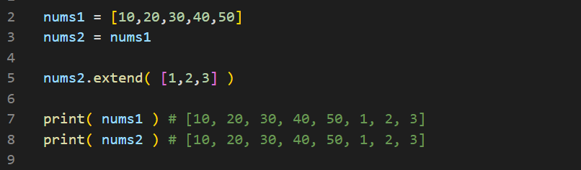

We know why this happens

both nums1 and nums2 reference to the same list in the memory

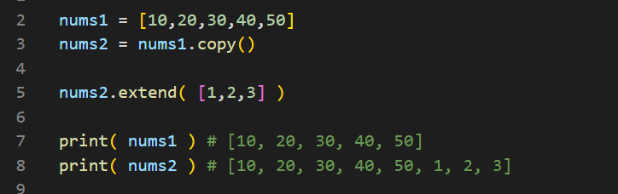

.copy( ) method solves the problem for this type of list, since this is **1-dimensional** list

.copy( ) method only makes the copies of values for **only one-level**

If there is **2-d, or 3-d** list then .copy( ) method fails

.copy( ) does the shallow copy

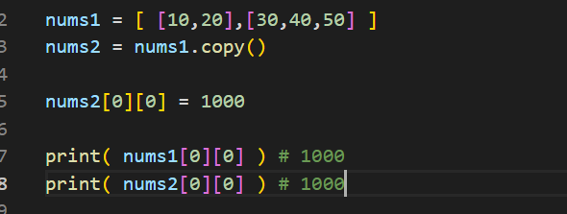

To solve this

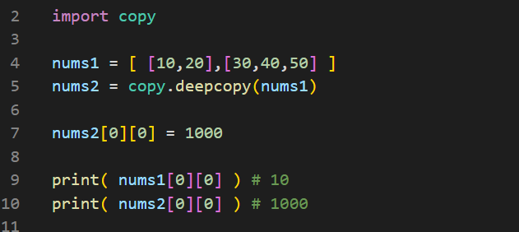

Import a module called copy, and use the **copy.deepcopy( )** method